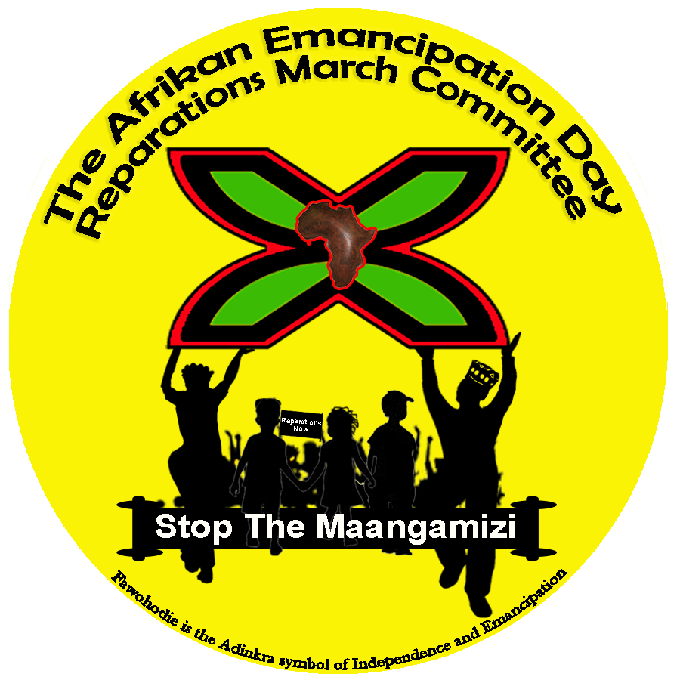
Afrikan Emancipation Day – Pan Afrikan Reparations Rebellion Groundings
1st Mosiah – Max Roach Park and Windrush Square

Stalls/Traders Policy
Introduction
Greetings Prospective Stallholder.
As co-organisers of Pan-Afrikan Reparations Rebellion Groundings (PARRG) taking place on 1st Mosiah (August) 2022, we are prioritising applications for stalls which provide essential sustenance, education or are otherwise providing essential services which are contributing to building the political economy of the International Social Movement for Afrikan Reparations (ISMAR). Building a political economy is about building an economy based on co-operative economics for the purposes of Nation Building, which is quite different to what many of us are involved in; ‘Black’ consumerism for our personal endeavours as sole traders.
An essential aspect of this ISMAR-building is contributing to economic repairs in ways and means that contribute to prefiguring the Post-Reparations Global Order in Afrikan Liberation Perspective envisaged and being self-actualised as: a repaired Afrika and our sense of Afrikan peoplehood in a repaired multipolar and pluriversal world of global justice known as Maatubuntuman in Ubuntudunia. So we are bringing our stalls policy in line with the overall purpose of the ISMAR, in which stall holders need to see themselves as part of the movement, part of the rebellion groundings, rather than being there to generate income for personal endeavours as sole traders.
The 1st of Mosiah, we engage our communities in ‘groundings’ about how best to wage our Pan-Afrikan Reparations Rebellion by utilising the principles and tactics of non-violent direct action in the process of securing the cessation of violations against us and guarantees of non-repetition of the Maangamizi (Afrikan Hellacaust) in order that we can transform our collective futures. So, those who are simply seeking to trade goods and services and who are not engaged in cooperatives or other cooperative economic endeavours conducive to ISMAR-building are not best placed to have stalls as part of the PARRG 2022. There are 364 other days of the year when Afrikan Marketplaces can occur, we co-organise the PARRG as a day of sacred protest and given the way in which our people have and continue to be bought and sold (out), we are calling for our community members to engage in a day of *material fasting from materialism and consumerism and the usual practice of 'buying and selling' which has become characteristic of many Afrikan Heritage Community events in the UK.
We see this as a form of economic repairs protest action conducive to the overall purpose of the PAARG and have introduced this policy for stalls at the PARRG 2022 in remembrance of our enslaved and colonized Afrikan Ancestors and their ascendants whose lives were and continue to be sacrificed to racial-capitalist exploitation, materialism and greed. Hence why we are giving priority to applications for stalls which provide essential sustenance, education or are otherwise providing essential services which are contributing to building the political economy of the ISMAR.

So what types of stalls meet the criteria?
As we are prioritising applications for stalls which provide essential sustenance, education or are otherwise providing essential services which are contributing to building the political economy of the International Social Movement for Afrikan Reparations (ISMAR), we welcome the following stalls:
Food and drink stalls – ensuring a variety of dietary requirements are provided for.
Educational Stalls – Afrikan Books for adults and children of all genres, DVDs/CDs of progressive Afrikan centred material, Afrikan centred games and puzzles
Information Stalls – Information about Afrikan led organisations, events and campaigns that contribute to Afrikan community self-repair efforts. Such stalls are not permitted to sell any products other than drinks as a fundraising effort for their organisation/campaign/event.
We will not be considering applications from stalls that sell:
- Skin/hair care products
- Jewellery
- Clothing
- Homeware
- Footwear
- Arts & Crafts

As co-organisers, we reserve the right to decline any application and stalls will be checked on the day to ensure they are authorised by the organisers of the Pan-Afrikan Reparations Rebellion Groundings (PARRG). We trust that all traders will treat us with the courtesy and consideration offered to them during this booking process and on the 1st Mosiah in the sprit of building Ujamaa for Maatubuntuman.

What are the cost of stalls?
Food stalls - £200
Education Stalls £50
Information stalls £20

How do can I apply for a stall?
Email info@reparationsmarch.org with ‘stall enquiry’ in the subject line
Please note: There are limited spaces for stalls and so information and education stalls will be allocated on a first come first served basis.
Food Stalls will be allocated based on a joint criterion of first come and first served AND the type of food being provided to ensure there is a dietary range.

We have taken this decision on the basis of the need to more effectively focus our efforts towards building the (ISMAR), which will in itself help harness our communities’ capability to effect and secure Holistic Reparatory Justice known as Planet Repairs (the nexus of reparatory, environmental and cognitive justice) by our own People’s Power*. We thank you in advance for your overstanding and cooperation.

Afrikan Emancipation Day Reparations March Committee (AEDRMC)
Stop The Maangamizi: We Charge Genocide/Ecocide Campaign (SMWeCGEC)
Glocal Afrikan Reparations Forum of London (GARFOL) 28/06/2022

For further information on this year’s Pan-Afrikan Reparations Rebellion Groundings please visit:
http://www.reparationsmarch.org/reparations-march/

https://stopthemaangamizi.com/2022/06/20/parrg-theme-2022-sankofaagro/

https://web.facebook.com/GARFOLUK

